|  |
| --- |
|  |



**14 June 2013** **The Weekly Bulletin of Rotary Club of Kathmandu Mid-Town** **Bc-14.6/012-13**

**District : 3292 Web: www.rotarymidtown.org.np Club Id : 26776**

**JUNE IS FELLOWSHIP MONTH**

Rotary International has established specific policies for forming a Rotary Fellowship. The RI Board of Directors evaluates each prospective group before deciding whether to formally recognize it. However, each fellowship operates independently of RI, with its own rules, dues requirements, and administrative structure. Membership is open to all Rotarians, Rotarian spouses, and Rotaractors.

Friday, 7 June:

Guest Speaker, Ms Karin Puttkammer gave her presentation on “Construction of a School Canteen for a Higher Secondary School in Chyangli". The speaker elaborated the School Canteen Project in Jeevan Jyoti Higher Secondary School in Gorkha. The project is supported and initiated by German Ama group with the help of Neplese Humanitarian Help Organisaton (NHHO). Most of the students are from Kumal ethnic group, and they remain without any lunch/tiffin throughout the day in the school. The project was initiated considering that each children can spend Rs 5 to 8 for one lunch. As part of the project a water storage tank has already been constructed and the design for the canteen building is also completed. The canteen will have the capacity for 600-800 children and now NHHO is seeking financial support to realize and complete this project.

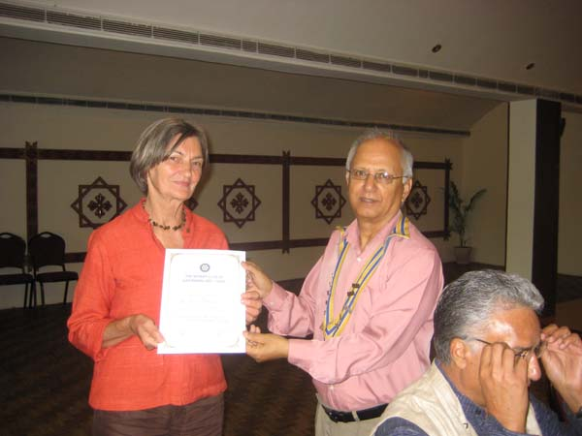

*President Devendra handing over a certificate of appreciation to guest speaker Karin Puttkammer*

# Weekly Meetings and Programs :

|  |  |  |
| --- | --- | --- |
| Date | Program/Speaker | Program/Topics of Presentation |
| 14 June 2013 | Jerome Edou | Declare Nepal Himalayas a Plastic (Bags & Bottles) Free Zone |
|  |  |  |

Friday, 14 June:

Mr Jerome Edou, a Frech national, residing in Nepal for last 2 decades, will be our Guest Speaker. He will be talking on his efforts to keep Himalayas a plastic free zone.

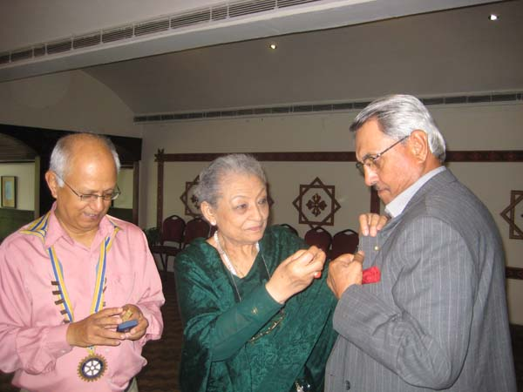 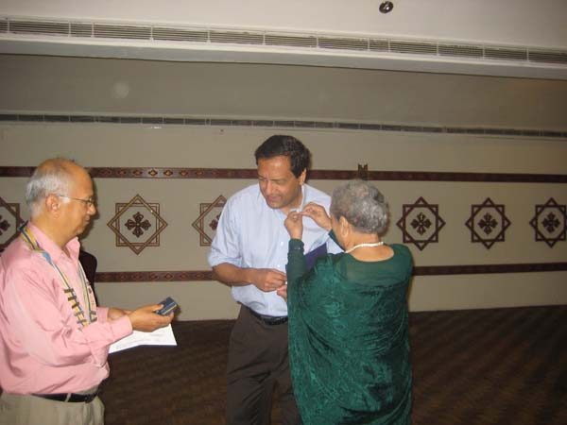

PP Ambica providing PHF+2 level pin to Rtn Krishna NS Thapa Rtn Dr Buddha Basnet receiving PHF pin and certificate

[**Biocentrism / Robert Lanza’s Theory of Everything**](http://www.robertlanza.com/biocentrism-how-life-and-consciousness-are-the-keys-to-understanding-the-true-nature-of-the-universe/)**:**

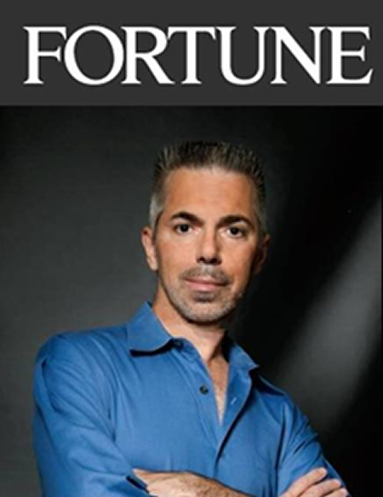

Every now and then, a simple yet radical idea shakes the very foundations of

knowledge. The startling discovery that the world was not flat challenged and

ultimately changed the way people perceived themselves and their relationships

with the world. “If the earth were really round,” it was argued, “Then the people at

the bottom would fall off.” For most humans of the 15th century, the notion of

Earth as ball of rock was nonsense. The whole of Western natural philosophy is

undergoing a sea change again, forced upon us by the experimental findings of

quantum theory. At the same time, these findings have increased our doubt and

uncertainty about traditional physical explanations of the universe’s genesis and

structure.

Biocentrism completes this shift in worldview, turning the planet upside down again with the revolutionary view that life creates the universe instead of the other way around. In this new paradigm, life is not just an accidental byproduct of the laws of physics.

Biocentrism takes the reader on a seemingly improbable but ultimately inescapable journey through a foreign universe—our own—from the viewpoints of an acclaimed biologist and a leading astronomer. Switching perspective from physics to biology unlocks the cages in which Western science has unwittingly managed to confine itself. Biocentrism shatters the reader’s ideas of life, time and space, and even death. At the same time, it releases us from the dull worldview that life is merely the activity of an admixture of carbon and a few other elements; it suggests the exhilarating possibility that life is fundamentally immortal.

Biocentrism awakens in readers a new sense of possibility and is full of so many shocking new perspectives that the reader will never see reality the same way again.

BIOCENTRISM : How Life and Consciousness are the Keys to Understanding the True Nature of the Universe.

“Like “*A Brief History of Time*” it is indeed stimulating and brings biology into the whole. Any short statement does not do justice to such a scholarly work. Almost every society of mankind has explained the mystery of our surroundings and being by invoking a god or group of gods. Scientists work to acquire objective answers from the infinity of space or the inner machinery of the atom. Lanza proposes a biocentrist theory which ascribes the answer to the observer rather than the observed. The work is a scholarly consideration of science and philosophy that brings biology into the central role in unifying the whole. The book will appeal to an audience of many different disciplines because it is a new way of looking at the old problem of our existence. Most importantly, **it makes you think**.”

*Source:* Nobel Prize Winner E. Donnall Thomas **/**Internet News

**Committee Chairpersons' Column:**

**???**

**Past Presidents' Column:**

We all remember that on 22nd March evening the Club's regular breakfast meeting was re-scheduled as dinner meeting at Hotel Annapurna for bidding farewell to Rtn Buddha Singh Laishram, who was scheduled to return to India on 25 March after completing his assignment tenure in Surya Nepal. And we did bid him farewell and thanked him for serving the Club and contributing as well as taking part in many Club and Rotaract activities. So he has left the Club and returned to India.

It is not understood why he has regularly been granted *'leave of absence'* in each of meeting minutes since 12 April. Is he on leave ?

PP RR Shrestha

However we define peace, whatever peace means to us, we can bring it closer through

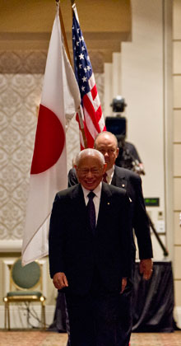

service. Peace, in all of the ways that we can understand it, is a real goal, and a realistic

goal for Rotary. Peace is not something that can only be achieved through treaties, by

governments, or through heroic struggles. It is something that we can find, and that we can

achieve – every day, and in many simple ways.

**RI President Sakuji Tanaka**

**On lighter side** :

Click here ⇩



**A Thought for the Day:**

***Fight with your strength, not with others' weakness;***

***True success lies in your effort and not in others' defeat !***

**Great Quotes:**

***“Kind hearts are the gardens;***

***Kind thoughts are the roots;***

***Kind words are the flowers;***

***Kind deeds are the fruits;***

***Take care of your garden,***

***And keep out the weeds,***

***Fill it with sunshine, kind words and kind deeds”***

- Henry Wadsworth Longfellow

*courtesy:* Rtn Dr Isabella C Bassingana Khadka

NB: Send any informations/photos that may be of interest to the Club or Rotarians in general to

BC Editor: RR Shrestha email: rryesrr@gmail.com

## 14 June 2013 The Weekly Bulletin of Rotary Club of Kathmandu Mid-Town bc-14.6/012-13